Chapter 1

What does pathology have to do with disease ecology? Linking pathogenesis to viral spillover dynamics

**Introduction**

Interspecies pathogen transmission is a multifactorial process with both extrinsic drivers, and intrinsic pathogen and host factors playing major roles in the process (Plowright et al. 2017, Becker et al. 2019, Ellwanger and Chies 2021). Viral traits such as being enveloped(Valero-Rello and Sanjuán 2022), being able to replicate in the cytoplasm (Pulliam and Dushoff 2009) have been suggested to play a role in viral spilloover into novel species. Recent work has looked even more so at the genotypes of viruses as a predictor of zoonotic potential(Mollentze et al. 2021). Host factors often studied have been phylogenetic distance between hosts (Guth et al. 2019)and more recently phylogenetic aggregation(Park 2019). Phylogeny is likely to capture a broad range of host biological traits that faciliate cross species transmission. Both host and viral factors have been included in predictive models of viral spillover (Olival et al. 2017). Whilst these host and viral factors are vitally important, they must be viewed through the lens of ecological viability of a spillover event happening and these extrinsic drivers are just as important (Engering et al. 2013, Borremans et al. 2019). Whilst there has been much investigation of specific pathogen and host traits involved in cross species transmission, there has been little research on the interplay between host and pathogen in disease spillover models **figx**. We believe there is a knowledge gap when it comes to the role of disease pathogeneis in viral spillover.

The potential role of infectious disease pathogenesis, defined as the manner in which a pathogen infects, replicates within a host and is transmitted between hosts in predictive models of cross-species disease transmission was raised by Pulliam et al in 2009, but it has proven to be a difficult question to answer(Pulliam and Dushoff 2009).

Ecological Drivers

Pathology

Viral Traits

Host Traits

Major factors influencing pathogenesis include the cellular receptor used by the virus for attachment to host cells and the distribution of those receptors within different tissues and/or organs. The cellular-level mechanisms of pathogenesis are known in well-studied viral systems such as influenza, however, much of that detailed knowledge is likely to be absent in many cases, therefore cell tropism and organ systems affected can serve as a proxy to study how infectious disease pathogenesis is related to cross species transmission. Additionally, the method of within-host spread of the pathogen may play an important role in determining whether disease spread can occur in the ‘recipient’ host species

The important steps in a viral lifecycle in a host are:

1. Primary transmission
2. **Entry and local replication**
3. **Dissemination within host**
4. **Secondary replication**
5. Shedding/secondary transmission



1.

4.

5.

3.

2.

All of these steps can shape pathogenesis in some way however the major stages that play a role in pathogenesis are the within host stages of entry and local replication, dissemination within the host, and secondary replication. Pathogenesis therefore plays a key role both in the link from primary transmission to infection and to that of secondary transmission. This is also the case when it comes to cross species transmission or spillover of viral pathogens. . Knowledge of viral-host interactions can infer if transmission to a new host will be productive. Similarly, dissemination within a host and organ tropism can predict shedding and likely secondary transmission. One can see how the pathogenesis of a viral infection could play a critical role in the transmission dynamics/ecology/epidemiology of a pathogen

*Viral Entry and local replication*

The initial “decision” for a virus upon encountering a new potential host is that of receptor selection and attachment. Contacting a compatible receptor allows the virus to attach to and gain entry to the host cell and consequently access the cellular machinery it requires for its replication cycle. Viruses that can infect multiple hosts tend to use an evolutionarily conserved receptor.(Woolhouse et al. 2012) A good example of this would be rabies virus, which uses the nACh-receptor which is very conserved across all mammals, and rabies has been shown to possess the ability to infect all eutherian mammals.(Marston et al. 2018) Another option is to have multiple potential receptors that can be used. Foot-and-mouth disease virus has at least three potential integrin receptors along with Fc receptors it can use, giving it the ability to infect most known cloven-hoofed mammals (Duque and Baxt 2003). This ability to utilize multiple receptors increases the likelihood of encountering a suitable receptor when the virus contacts a novel host.

*Dissemination within host*

With regards to viral dissemination within a host and the potential role of this in spillover, canine distemper can serve as an illustrative example of the importance of within host dissemination and cross species transmission, Canine distemper virus is considered a multi-cell and multi-host pathogen that has the ability to infect three different types of host cells; epithelial, lymphoid, and neurological cells (Rendon-Marin et al. 2019).  CDV predominantly uses SLAM/CD150 as a receptor, which is expressed on activated T- and B- lymphocytes, and dendritic cells (DCs) and macrophages. During the first stages of infection within the host, resident DCs and alveolar macrophages in the respiratory tract are infected along with other cells which express CD150 in the alveolae. Infected cells carry the virus to the draining lymph node where resident activated T-cells and B-cells are infected through the CD150 receptor, resulting in virus amplification and the initiation of primary viremia. The virus gets disseminated to secondary lymphoid organs and subsequently a systemic spread through the entire immune system, then disseminates to brain, liver, skin, gastrointestinal tract, genitals, and respiratory mucosal surfaces. This rapid systemic spread, particularly to respiratory mucosa results in the potential for rapid transmission dynamics through close contact populations. This pathology of using the lymphatic system to spread systemically is almost certainly involved in this virus’ ability to infect a wide range of species.

*Secondary Replication*

In addition to receptor selection/attachment, a large part of cellular pathogenesis and within-host infection dynamics are controlled by the distribution of the receptor used by the virus within or across organ systems that alllow secondary replication at distant sites. The most studied system of receptor distribution is in different host species infected by influenza virus. Avian and human influenza strains preferentially use differently terminated sialic acid receptors with SAα2,3Gal (avian receptor) and SAα2,6Gal (mammalian receptor) terminated saccharides distributed in the upper respiratory tract of birds and humans, respectively.(Kumlin et al. 2008) However, both types of receptor are also present in the upper respiratory tract of pigs giving rise to the pigs as a “mixing vessel” theory of flu recombination and evolution (Ma et al. 2008). As the pig upper respiratory tract expresses both of these receptors that allows for coinfection with an avian and human strain and recombination to produce a highly pathogenic strain that is more transmissible in people than an avian strain, such as was the case in the 2009 swine flu epidemic.(ref)Tissue tropism of avian Influenza has been shown to influence spillover from wild Birds to Pigs (Zhang et al. 2020). Additionally, distribution of receptors in humans is of import. Humans possess SAα2,3Gal receptors, but only in their lower respiratory tract (de Graaf and Fouchier 2014). So while people do occasionally become infected with avian influenza, this subtle difference in receptor distribution plays a huge role, both in disease pathogenesis and in transmissibility of infection. The presence of the virus and subsequent replication in the lower respiratory tract results in a much more severe infection with higher morbidity and mortality than a typical human strain of flu. Additionally, the fact that the virus can not replicate in the upper respiratory tract makes it difficult for the virus to be transmitted via respiratory aerosol.

Waterfowl are considered as the primary wild reservoir of avian influenza strains and their role in this again partly comes down to receptor distribution. The SAα2,3Gal receptors used by the influenza virus are present in large amounts in the intestinal tract of many species of mmigratory waterfowl (Costa et al. 2012). Waterfowl belonging to the *Anatidae* family (ducks, geese, and swans) are the primary reservoir of all 16 hemagglutinin and 9 neuraminidase subtypes of avian influenza viruses (Hansbro et al. 2010). Migration by these birds results in the inoculation of waterways with live influenza virus which is relatively stable in the water (Blagodatski et al. 2021). Additionally, there is also the potential for free-ranging domestic fowl to be exposed to faeces containing avian influenza from these birds. This illustrates how pathological features of infection and ecology can interact to directly influence viral transmission dynamics.

Here, we synthesize available literature on cross-species transmission events along with pathological data to determine how aspects of viral pathogenesis affect cross-species transmission in RNA viruses. First, we identify how tissue tropism and the mechanism of within host spread influence cross species transmission. We then, we assess the role cellular pathogenesis, including cell tropism, cellular receptor, plays in cross species transmission. We hypothesize that RNA virus tissue tropism, and those using broadly conserved receptors or those that can use alternate receptors will be more likely to transmit to alternate hosts.

**Methods**

**Data acquisition and overview**

A search of the PubMed database was performed as described below. These search results were then screened using the *metagear* package in R according to the Prisma guidelines fig X.**.** Following this a secondary search was conducted to provide known pathological data for each virus.

The resulting data were imported into R Studio (version 1.3.1056). A detailed description of data analysis is contained in the scripts within the project repository (https://github.com/JJWilson1991/......). All analyses were conducted in the R programming environment (version 3.5.3.). References to packages in this methods section indicate specific packages used within the R environment to perform analyses.

|  |  |
| --- | --- |
| **Exclusion criteria** | **Inclusion criteria** |
| **Experimental Data**  **Review article**  **Irrelevant** | **Directly transmitted**  **Evidence of transmission from reservoir to spillover species. (In descending strength of support)**  **-molecular evidence (virus recovery, PCR etc.)**  **-phylogenetic**  **-serological**  **-epidemiological** |

**literature search**

A literature search was performed of the PubMed data base according to Prisma guidelines () ref. The search terms described in figure x were used with the results being screen for eligibility using the Metagear package in R. Eligibility criteria described in table x.

**FigX: Search terms used in PubMed search**

**(((RNA virus) AND (((((Spillover) OR (cross-species transmission)) OR (host-switching)) OR (interspecies transmission)) OR (zoonosis))) NOT (Covid)) NOT (Review[Publication Type])**

Following inclusion in the study, data relating to the cross-species transmission event were recorded from each article, listed in table X. The pathological traits recorded from the secondary search are also listed in table x.events were defined as zoonotic, anthroponotic or not zoonotic. “Not zoonotic” being defined as a virus which is not considered to infect humans. An “anthroponotic” event is defined as a virus which has been transmitted from a human reservoir to another species.

|  |  |
| --- | --- |
| **Transmission event data recorded** | **Pathological data recorded** |
| **Virus (Species, genus, family, order)**  **Reservoir host (Species, genus, family, order)**  **Spillover host Species, genus, family, order)**  **Zoonotic traits** | **Within host spread mechanism**  **Cellular receptor used**  **Receptor distribution**  **Cellular tropism**  **Organs/systems affected** |

Table X

**Multiple correspondence Analysis**

Records identified from*:

Databases (n = 1) (NCBI)

Records removed *before screening*:

Duplicate records removed (n =0)

Records removed for other reasons (n =0)

Records screened

(n =7258)

Records excluded**

(n = 2976)

Reports sought for retrieval

(n =680)

Reports not retrieved

(n =0)

Reports assessed for eligibility

(n =680)

Reports excluded:

N=

Studies included in review

(n = 189)

**Identification of studies via databases and registers**

**Identification**

**Screening**

**Included**

Figure X

To analyze the relationship between pathological parameters, multiple correspondence analysis (MCA) was conducted. MCA is a descriptive technique designed to measure correspondence between the rows and columns in tables of data. The object of MCA is to visualize the relationship of categorical variables. Correspondence analysis is used to explore the relationship between variables by comparison with distance in multiple dimension space. The first two dimensions can usually explain most of the variation seen in the data. Following data processing a total of n=213 rows along with 31 columns were uses for MCA. The MCA was also repeated with just the distinct viruses n=52, to remove bias in the correspondence caused by viruses which occur often in the literature in spillover events between multiple different species e.g., influenza. Multiple correspondence analysis was conducted on the data using the package *FactoMineR ref.*

**Hierarchical cluster analysis**

We used hierarchical cluster analysis to group viruses into pathologically similar clusters. Specifically, we constructed a dissimilarity matrix using the Gower distance (Gower 1971) with the `daisy` function from the `cluster` package. This matrix was then used with the ‘hclust’ function in the ‘stats’ package to perform agglomerative clustering on this distance matrix. We next visualized the results of our hierarchical cluster analysis as a dendrogram with the ‘dendextend’ and `factoextra` packages(Galili 2015, Kassambara and Mundt 2017).

**Results**

A total of 189 articles were entered into the database and following processing, this resulted in n=213 unique entries of virus-reservoir host-spillover host interactions. This was comprised of n=52 distinct viruses. The unknown data for pathology-related variables are summarized in table x.

|  |  |
| --- | --- |
| **Pathology variable** | **Unknown data proportion** |
| Cellular Receptor | 14/52 |
| Within-host spread mechanism | 14/52 |
| Cell tropism | 5/52 |
| Organ systems affected | 3/52 |

The most frequent reservoir host was humans (34/213) followed by pigs and dogs (supplementary). Spillover hosts was dominated by humans with 103/213 recorded. The nature of interactions between reservoir hosts and spillover hosts is represented in figure X. From the 52 viruses recorded there were 33 different cellular receptors plus a further 14 unknown receptors. The most common pathologies recorded for within-host spread, cell tropism and organs systems are represented in figure x.

Table X

Table X

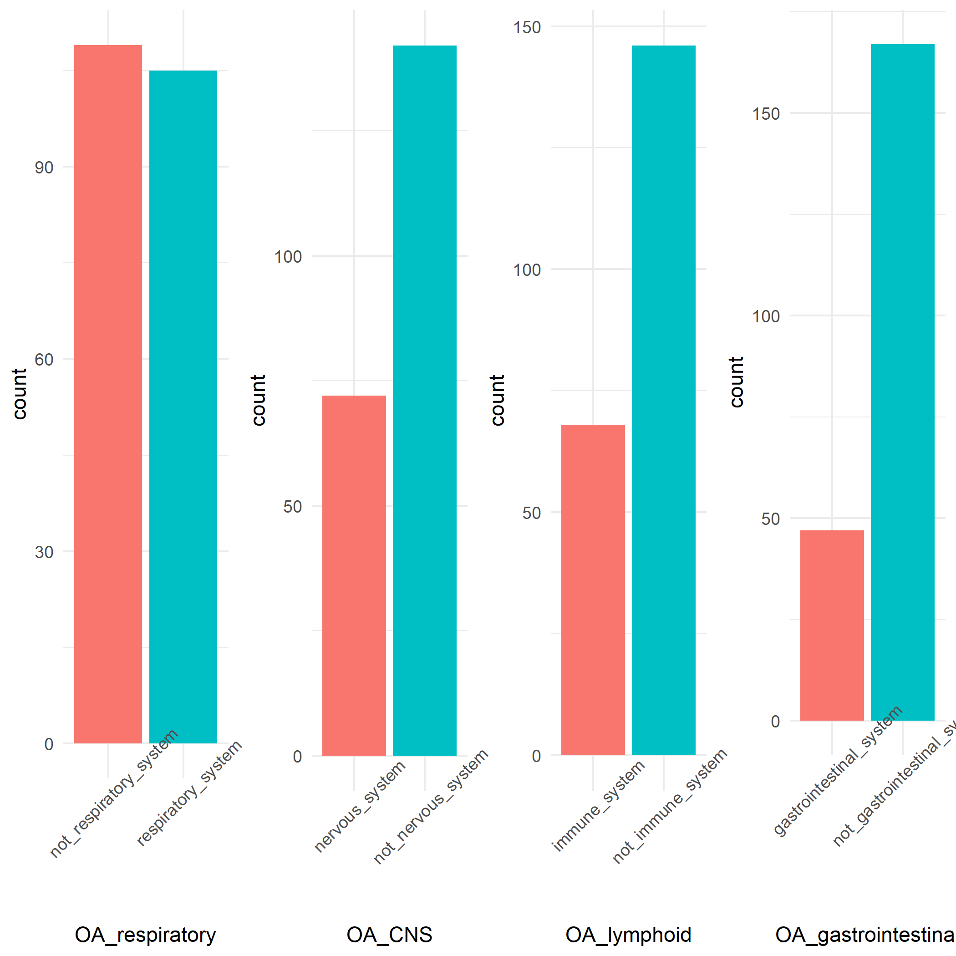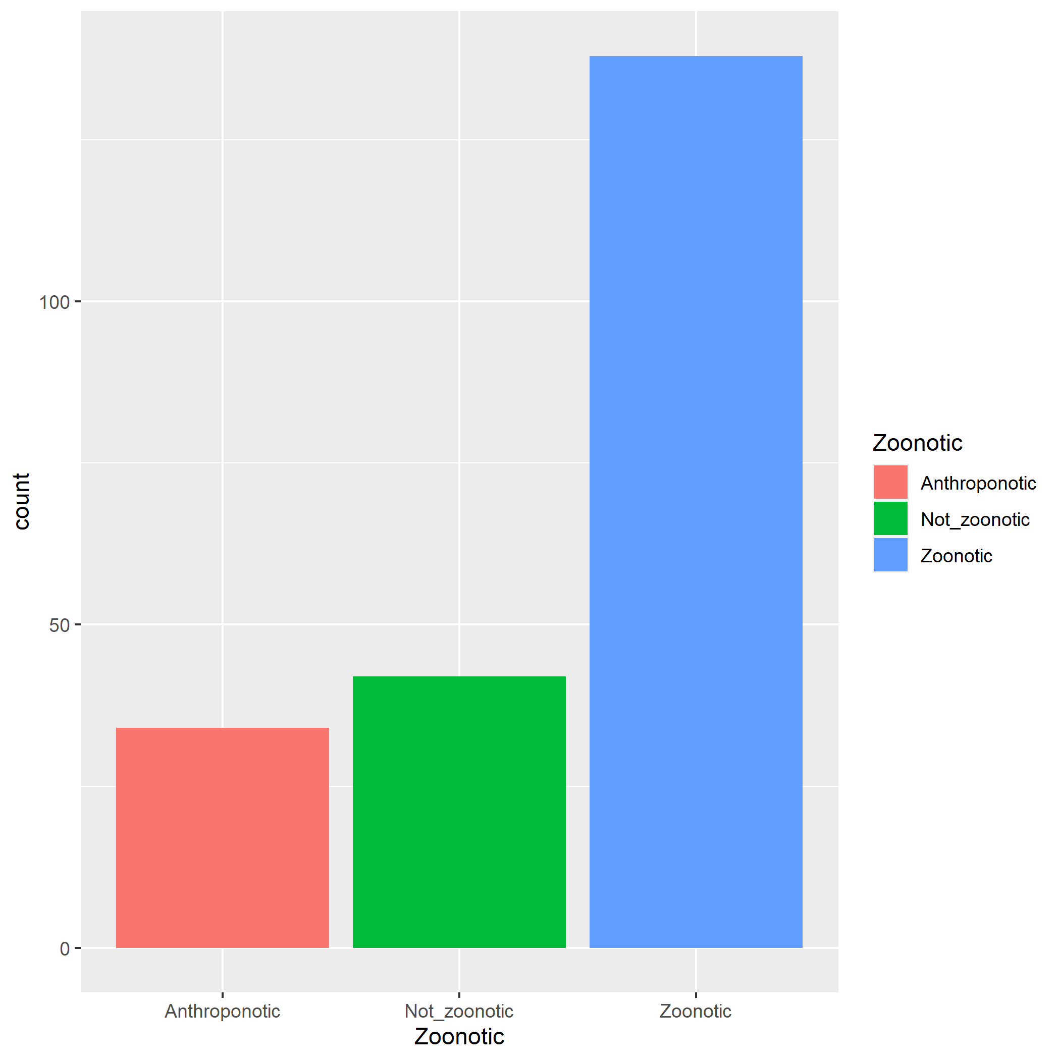

Fig X

**Multiple correspondence analysis**

The first two dimensions of the MCA explain 35% of the variance in the data. The major variables which contribute to the first two dimensions are shown in figure x. The MCAfor individual host interactions (figure X) clusters epithelial spread and respiratory pathology with anthroponosis, suggesting an association between these variables. There also appears to be an association between lymphocytic tropism and not being zoonotic. 95% confidence ellipses for anthroponotic cluster separately from not_zoontoic, suggest pathological features differ. (fig X).

The MCA was repeated with distinct viruses (fig X) Distinct viruses being a viral species which has been involved in a spillover event, so that there is one entry per virus. Whereas in the original search and analysis many viruses had multiple entries as they were involved in multiple spillover events involving different species. In this case gastrointestinal pathology is associated with not zoonotic in addition to lymphocyte tropism. The zoonotic ellipses for the distinct virus MCA have the zoonotic ellipse as a smaller ellipse within a larger ellipse for not zoonotic. (fir X)

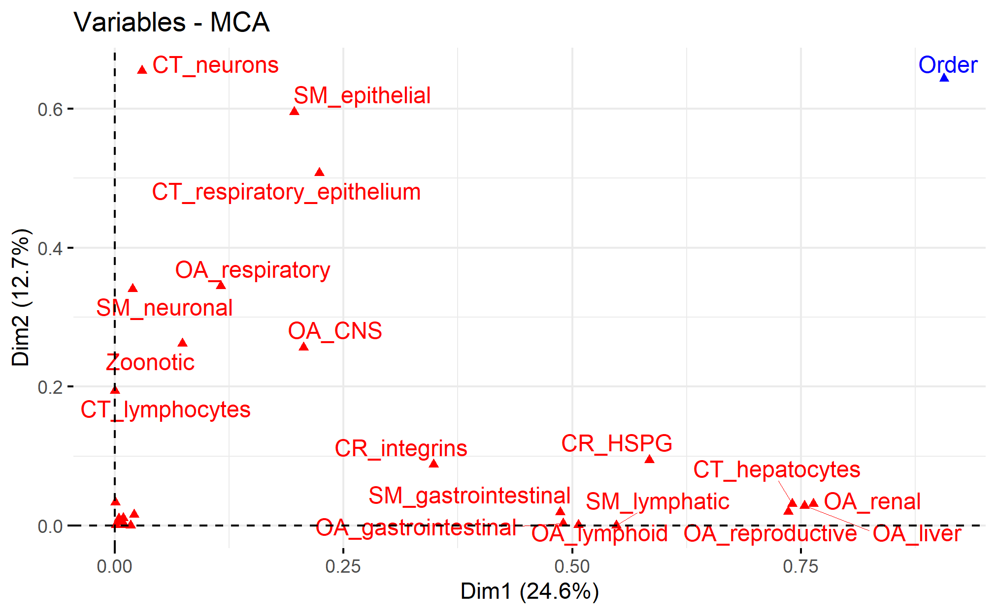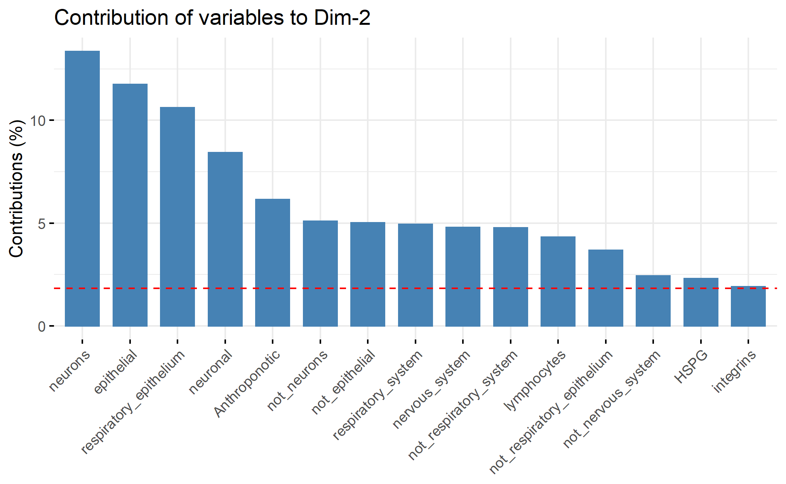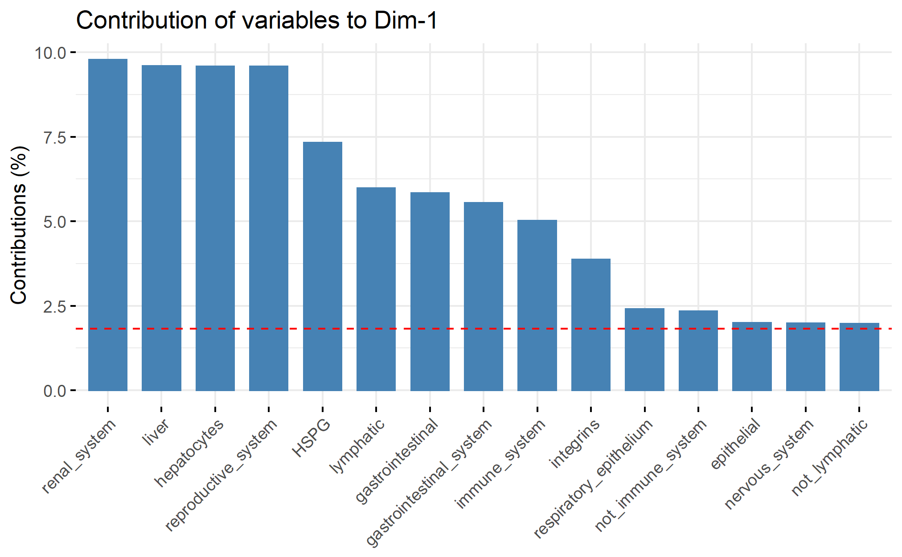

Figure X

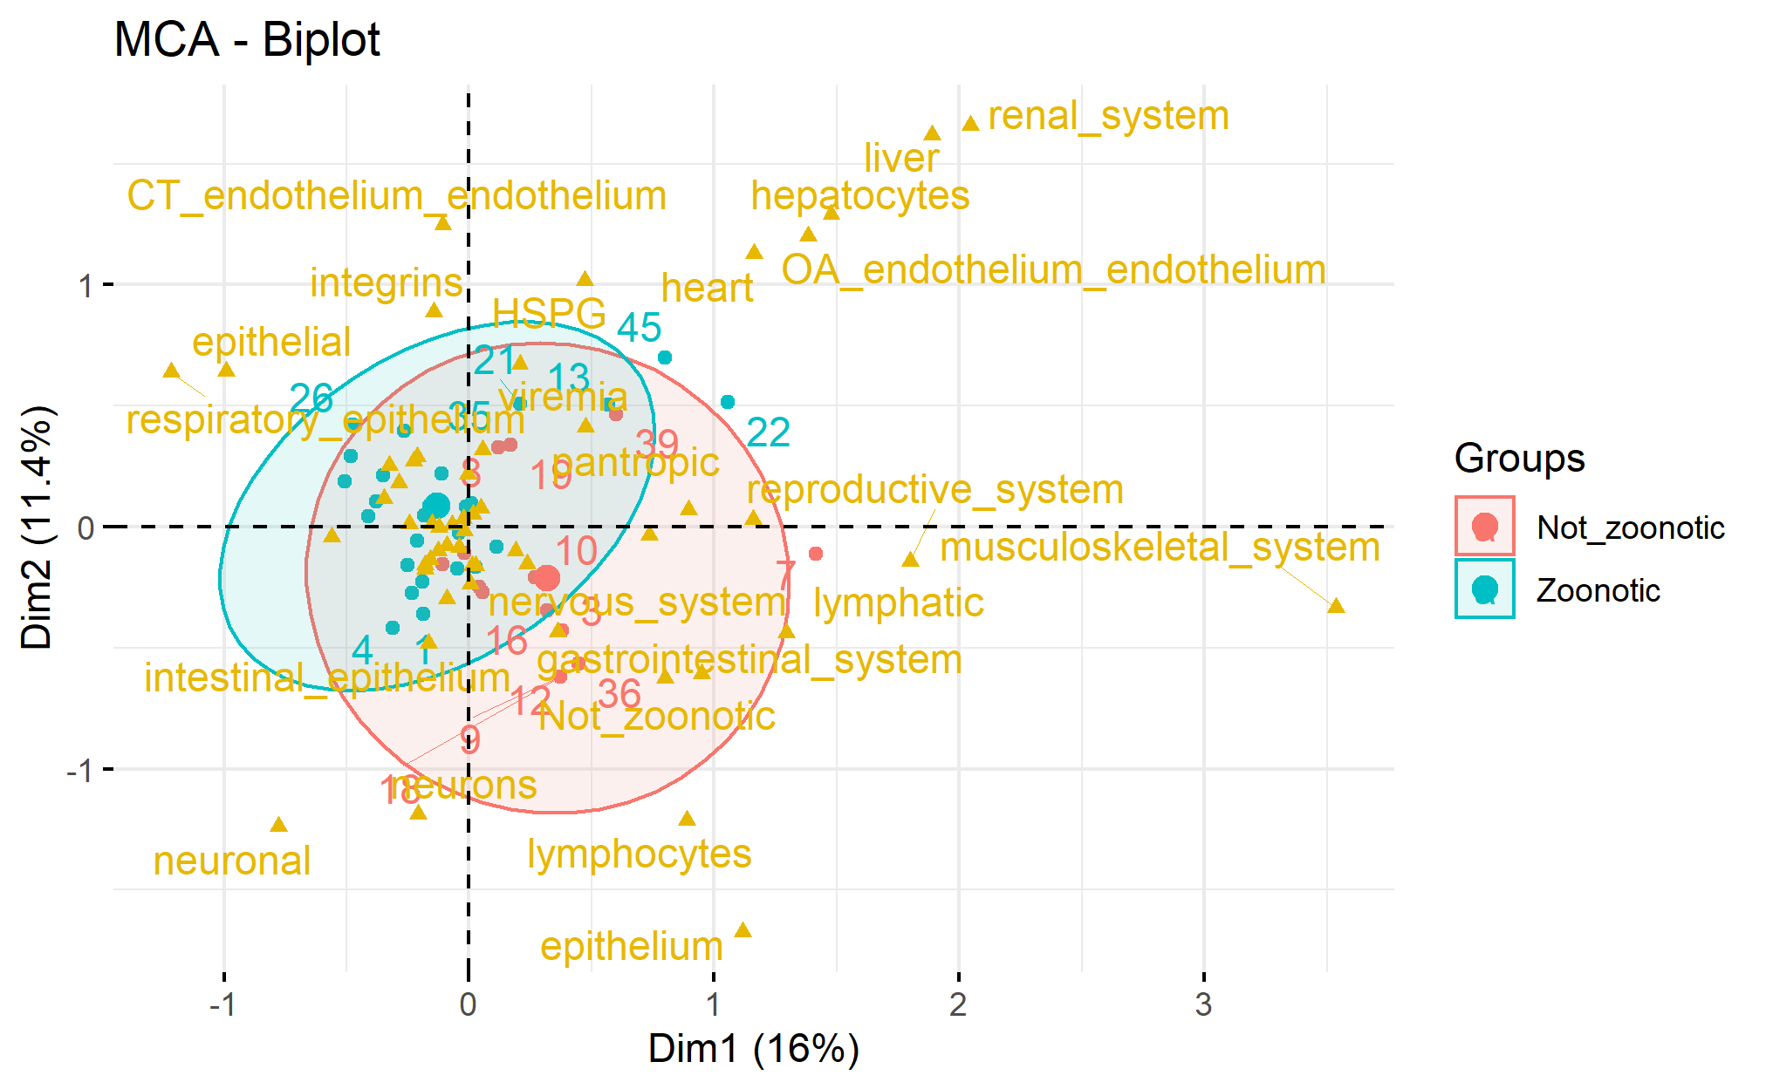

Fig X

Fig X

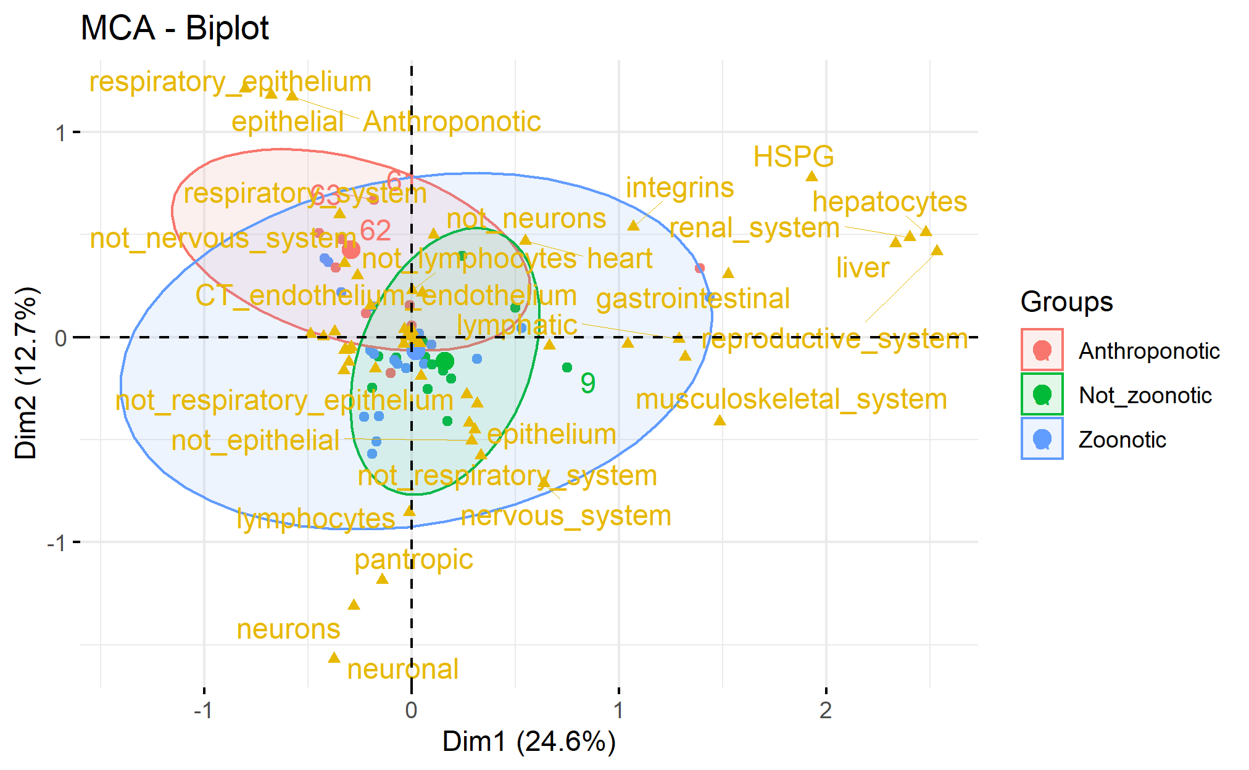

**Hierarchical** **cluster analysis**

When hierarchical cluster analysis is performed on the second data set of 52 viruses and their typical pathogenesis they tend to cluster into distinct groups based on pathology. Six main clusters were formed, with five of these based on pathology and morbilliviruses forming their own cluster. There were also an additional six “orphan viruses that did not cluster with any others based on pathology Figure X.

.

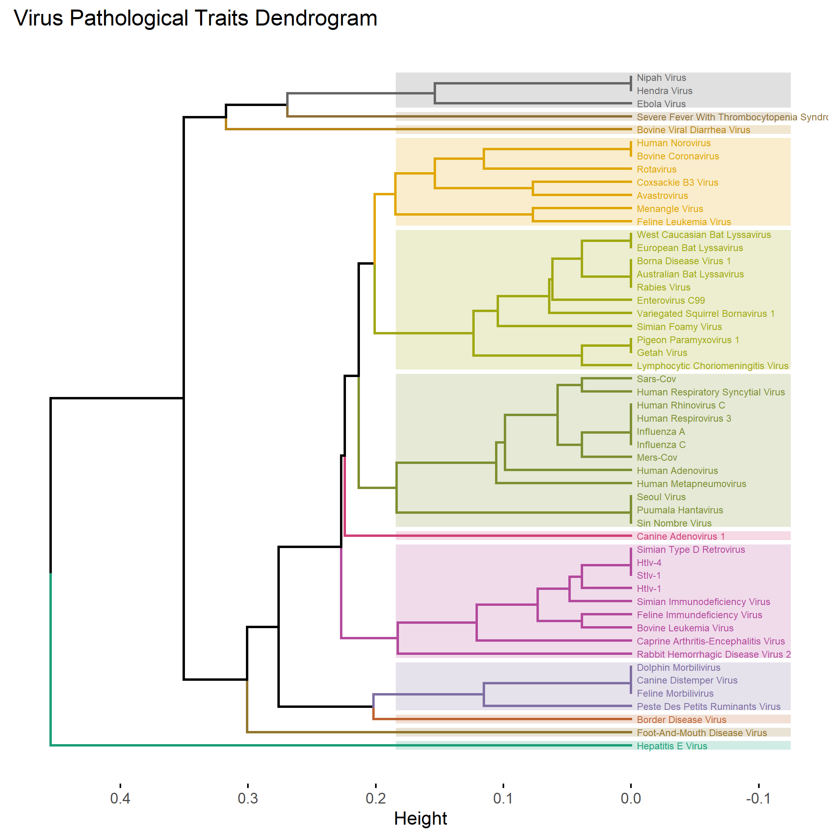

Neurological

Gastrointestinal

Respiratory

Endothelial

Immunological

Fig X.

Dendrogram generated from 52 distinct viruses and their pathological data.. To generate the dendrogram, each pathway was assigned codes reflecting its content; these data were then used to generate a distance matrix. We performed a hierarchical cluster analysis on the matrix to group similar pathological data. The dendrogram was cut to divide the tree into 12 clusters, each of which is represented by a different colour. The six major clusters are named based on the predominant pathology in each (in addition to the morbilivirus cluster)

Morbilliviruses

**Discussion**

The current study analyzed the results of a literature search for cross-species transmission events in RNA viruses and looked for trends in the pathological features associated with these infections.

The percentage of unknowns for pathological data increased the more microscopic the level of the pathological variable, with cellular receptors being the most unknown. Whilst one of the aims was to study cellular receptor trends from the 52 viruses recorded there were 33 different cellular receptors plus a further 14 unknown receptors While many of the cellular receptors for viral entry in the host are unknown, equally many of the recorded receptors are putative or just one piece of the cellular attachment and entry puzzle making this difficult to analyze. Although some basic types of receptors did occur regularly in integrins and HSPGS, suggesting that these may be a conserved group of receptors for a number of viruses, and are known to be widely spread receptors in hosts. Recent work has also begun to look at the potential role of sialic acid receptors as a conserved receptor involved in zoonotic infections (Kuchipudi et al. 2021)

64% of articles involved humans as either reservoir or spillover host highlighting the inherit human bias in cross species transmission research. Humans are in close proximity to spillover events involving them as reservoir or spillover hosts and can report symptoms etc., They also have a vested interest in research involving these diseases that affect them directly. This is reflected in the 4 most common viruses in the dataset; influenza A, rabies, hepatitis E and simian foamy virus which are all known to infect humans. In addition to cases involving humans themselves, 66% of records involved what would be considered a domestic species (either livestock or pet) as reservoir or spillover host, with only 8% of records involving neither humans nor domestic species. This demonstrates the inherent bias that exists in this type of data with either the proximity to these species resulting in reporting biases or the interest in surveillance of diseases in these species.

In addition to domesticated species, whereby contact is likely an important factor, the other major group of species with which humans exchanged viruses are primates. This is likely due to lower barriers to cross species transmission in this case due to phylogenetic relatedness (Olival et al. 2017, Guth et al. 2019)

The association between anthroponosis, those cases of virus transmission from human to other species and respiratory pathology may have to do with human behaviors. Respiratory pathology is generally caused by viruses with a respiratory droplet mode of transmission. Other methods of transmission less likely from humans due to human behaviors related to hygiene reducing the risk of faeco-oral transmitted pathogens and those transmitted by direct contact(Penakalapati et al. 2017). (Is there a reference for this) This was reflected in the MCA where zoonosis and anthroponosis formed a subset within a larger more variable group containing cross species events not involving humans. This may also reflect a narrower range of pathologies. The occurrence of the anthroponotic ellipsis as a smaller ellipsis as a smaller ellipsis with the zoonotic ellipsis in the MCA for the individual host MCA and the zoonotic ellipsis as a smaller ellipsis as a smaller ellipsis with a larger not zoonotic in the distinct virus MCA seems to reflect this. The importance of respiratory pathology in humans was shown again in the HCA with the respiratory cluster including only viruses with humans as spillover or reservoir hosts.

With the exception of influenza, respiratory tropic viruses tended to be transmitted between more closely related species. Do high barriers to infection due to mucosal immunity require more conserved receptors i.e., between more related species(Sato and Kiyono 2012).

Those viruses with primary neuronal tropism are known to have a broad host range. The neurological cluster of the dendrogram featured more variety in terms of hosts and viruses than other clusters.The receptor for rabies virus and possibly other lyssa viruses is the nicotinic acetylcholine receptor which is widely conserved between mammalian species.(Le Novere and Changeux 1995, Gotti and Clementi 2004) This feature of the pathogenesis of this virus helps to explain its broad host range and ease of transmission into novel species.

Despite being associated with cross species transmission events causing severe illness, such as hemorrhagic fever viruses, endotheliotropic viruses there were not many records with endothelial pathology and there wasn’t a strong correspondence with anything. This may be due to the difficulty in accessing this receptor.

Lymphoid tropism was associated with viruses categorized as not_zoontoic. This greater host range may be related to co-opting the host immune system to bypass some of these interspecific barriers or perhaps there may be conserved immunological virus receptors between species.

There are some outlying variables in the MCA e.g., muscle, caused by individual recordings, which are likely not important to overall trends in pathogenesis but highlight the importance of referring back to the actual data when interpreting MCA.

In the hierarchical cluster analysis, whilst there was some clustering based on viral phylogeny, this was not strict, with some phylogenetically related viruses not clustering together but instead clustering based on the pathology induced. With the HCA it is interesting to note that there are still a number of “orphan viruses” that don’t cluster well, highlighting part of the challenge here in that the interactions between virus and host that produces pathology is complex and can produce some unique outcomes.

There are two main points to take from this study. Firstly, there appear to be trends in pathological data which correspond to certain types of spillover event that merits further study in this area. Secondly, the current absence of high-quality data makes this area difficult to further analyze and calls for more collaboration and focused efforts amongst the scientific community to identify receptors which may be indicative of spillover risk. Elucidating the potential role of pathogenesis in cross species transmission can raise the possibility of trying to include some of this data into predictive frameworks of spillover risk.

**Cellular and immunological mechanisms influence host-adapted phenotypes in a vector-borne microparasite**

**(Lin et al. 2022)**

# Virulence mismatches in index hosts shape the outcomes of cross-species transmission

(Mollentze et al. 2020)

[Ecology, evolution, and **spillover** of coronaviruses from bats.](https://pubmed.ncbi.nlm.nih.gov/34799704/)(Ruiz-Aravena et al. 2022)

**The Evolution and Genetics of Virus Host Shifts**

**(Longdon et al. 2014)**

**Supplementary Materials**

|  |  |  |  |
| --- | --- | --- | --- |
| **Virus_Name** | **Order** | **Family** | **Genus** |
| Australian Bat Lyssavirus | Mononegavirales | Rhabdoviridae | Lyssavirus |
| Avastrovirus | Stellavirales | Astroviridae | Avastrovirus |
| Border Disease Virus | Amarillovirales | Flaviviridae | Pestivirus |
| Borna Disease Virus 1 | Mononegavirales | Bornaviridae | Orthobornavirus |
| Bovine Coronavirus | Nidovirales | Coronaviridae | Betacoronavirus |
| Bovine Leukemia Virus | Ortervirales | Retroviridae | Deltaretrovirus |
| Bovine Viral Diarrhea Virus | Amarillovirales | Flaviviridae | Pestivirus |
| Canine Adenovirus 1 | Rowavirales | Adenoviridae | Mastadenovirus |
| Canine Distemper Virus | Mononegavirales | Paramyxoviridae | Morbillivirus |
| Caprine Arthritis-Encephalitis Virus | Ortervirales | Retroviridae | Lentivirus |
| Coxsackie B3 Virus | Picornavirales | Picornaviridae | Enterovirus |
| Dolphin Morbilivirus | Mononegavirales | Paramyxoviridae | Morbillivirus |
| Ebola Virus | Mononegavirales | Filoviridae | Ebolavirus |
| Enterovirus C99 | Picornavirales | Picornaviridae | Enterovirus |
| European Bat Lyssavirus | Mononegavirales | Rhabdoviridae | Lyssavirus |
| Feline Immundeficiency Virus | Ortervirales | Retroviridae | Lentivirus |
| Feline Leukemia Virus | Ortervirales | Retroviridae | Gammaretrovirus |
| Feline Morbilivirus | Mononegavirales | Paramyxoviridae | Morbillivirus |
| Foot-And-Mouth Disease Virus | Picornavirales | Picornaviridae | Aphthovirus |
| Getah Virus | Martellivirales | Togaviridae | Alphavirus |
| Hendra Virus | Mononegavirales | Paramyxoviridae | Henipavirus |
| Hepatitis E Virus | Hepelivirales | Hepeviridae | Hepevirus |
| HTLV-1 | Ortervirales | Retroviridae | Deltaretrovirus |
| HTLV-4 | Ortervirales | Retroviridae | Deltaretrovirus |
| Human Adenovirus | Rowavirales | Adenoviridae | Mastadenovirus |
| Human Metapneumovirus | Mononegavirales | Pneumoviridae | Metapneumovirus |
| Human Norovirus | Picornavirales | Caliciviridae | Norovirus |
| Human Respirovirus 3 | Mononegavirales | Paramyxoviridae | Respirovirus |
| Human Rhinovirus C | Picornavirales | Picornaviridae | Enterovirus |
| Influenza A | Articulavirales | Orthomyxoviridae | Alphainfluenzavirus |
| Influenza C | Articulavirales | Orthomyxoviridae | Gammainfluenzavirus |
| Lymphocytic Choriomeningitis Virus | Bunyavirales | Arenaviridae | Mammarenavirus |
| Menangle Virus | Mononegavirales | Paramyxoviridae | Pararubulavirus |
| MERS-CoV | Nidovirales | Coronaviridae | Betacoronavirus |
| Nipah Virus | Mononegavirales | Paramyxoviridae | Henipavirus |
| Peste Des Petits Ruminants Virus | Mononegavirales | Paramyxoviridae | Morbillivirus |
| Pigeon Paramyxovirus 1 | Mononegavirales | Paramyxoviridae | Avulavirus |
| Puumala Hantavirus | Bunyavirales | Hantaviridae | Orthohantavirus |
| Rabbit Hemorrhagic Disease Virus 2 | Picornavirales | Caliciviridae | Lagovirus |
| Rabies Virus | Mononegavirales | Rhabdoviridae | Lyssavirus |
| Human Respiratory Syncytial Virus | Mononegavirales | Pneumoviridae | Orthopneumovirus |
| Rotavirus | Reoviridae | Reoviridae | Rotavirus |
| SARS-CoV | Nidovirales | Coronaviridae | Betacoronavirus |
| Seoul Virus | Bunyavirales | Hantaviridae | Orthohantavirus |
| Severe Fever With Thrombocytopenia Syndrome Virus | Bunyavirales | Phenuiviridae | Bandavirus |
| Simian Foamy Virus | Ortervirales | Retroviridae | Spumavirus |
| Simian Immunodeficiency Virus | Ortervirales | Retroviridae | Lentivirus |
| Simian Type D Retrovirus | Ortervirales | Retroviridae | Betaretrovirus |
| Sin Nombre Virus | Bunyavirales | Hantaviridae | Orthohantavirus |
| STLV-1 | Ortervirales | Retroviridae | Deltaretrovirus |
| Variegated Squirrel Bornavirus 1 | Mononegavirales | Bornaviridae | Orthobornavirus |
| West Caucasian Bat Lyssavirus | Mononegavirales | Rhabdoviridae | Lyssavirus |

BECKER, D. J., A. D. WASHBURNE, C. L. FAUST, J. R. C. PULLIAM, E. A. MORDECAI, J. O. LLOYD-SMITH, ANDR. K. PLOWRIGHT. 2019. Dynamic and integrative approaches to understanding pathogen spillover. Philos Trans R Soc Lond B Biol Sci 374: 20190014.

BLAGODATSKI, A., K. TRUTNEVA, O. GLAZOVA, O. MITYAEVA, L. SHEVKOVA, E. KEGELES, N. ONYANOV, K. FEDE, A. MAZNINA, E. KHAVINA, S. J. YEO, H. PARK, ANDP. VOLCHKOV. 2021. Avian Influenza in Wild Birds and Poultry: Dissemination Pathways, Monitoring Methods, and Virus Ecology. Pathogens 10.

BORREMANS, B., C. FAUST, K. R. MANLOVE, S. H. SOKOLOW, ANDJ. O. LLOYD-SMITH. 2019. Cross-species pathogen spillover across ecosystem boundaries: mechanisms and theory. Philos Trans R Soc Lond B Biol Sci 374: 20180344.

COSTA, T., A. J. CHAVES, R. VALLE, A. DARJI, D. VAN RIEL, T. KUIKEN, N. MAJO, ANDA. RAMIS. 2012. Distribution patterns of influenza virus receptors and viral attachment patterns in the respiratory and intestinal tracts of seven avian species. Vet Res 43: 28.

DE GRAAF, M., ANDR. A. FOUCHIER. 2014. Role of receptor binding specificity in influenza A virus transmission and pathogenesis. EMBO J 33: 823-841.

DUQUE, H., ANDB. BAXT. 2003. Foot-and-mouth disease virus receptors: comparison of bovine alpha(V) integrin utilization by type A and O viruses. J Virol 77: 2500-2511.

ELLWANGER, J. H., ANDJ. A. B. CHIES. 2021. Zoonotic spillover: Understanding basic aspects for better prevention. Genet Mol Biol 44: e20200355.

ENGERING, A., L. HOGERWERF, ANDJ. SLINGENBERGH. 2013. Pathogen-host-environment interplay and disease emergence. Emerg Microbes Infect 2: e5.

GALILI, T. 2015. dendextend: an R package for visualizing, adjusting and comparing trees of hierarchical clustering. Bioinformatics 31: 3718-3720.

GOTTI, C., ANDF. CLEMENTI. 2004. Neuronal nicotinic receptors: from structure to pathology. Prog Neurobiol 74: 363-396.

GOWER, J. C. 1971. A General Coefficient of Similarity and Some of Its Properties. Biometrics 27: 857-871.

GUTH, S., E. VISHER, M. BOOTS, ANDC. E. BROOK. 2019. Host phylogenetic distance drives trends in virus virulence and transmissibility across the animal-human interface. Philos Trans R Soc Lond B Biol Sci 374: 20190296.

HANSBRO, P. M., S. WARNER, J. P. TRACEY, K. E. ARZEY, P. SELLECK, K. O'RILEY, E. L. BECKETT, C. BUNN, P. D. KIRKLAND, D. VIJAYKRISHNA, B. OLSEN, ANDA. C. HURT. 2010. Surveillance and analysis of avian influenza viruses, Australia. Emerg Infect Dis 16: 1896-1904.

KASSAMBARA, A., ANDF. MUNDT. 2017. Package ‘factoextra’. Extract and visualize the results of multivariate data analyses 76.

KUCHIPUDI, S. V., R. K. NELLI, A. GONTU, R. SATYAKUMAR, M. SURENDRAN NAIR, ANDM. SUBBIAH. 2021. Sialic Acid Receptors: The Key to Solving the Enigma of Zoonotic Virus Spillover. Viruses 13.

KUMLIN, U., S. OLOFSSON, K. DIMOCK, ANDN. ARNBERG. 2008. Sialic acid tissue distribution and influenza virus tropism. Influenza and other respiratory viruses 2: 147-154.

LE NOVERE, N., ANDJ. P. CHANGEUX. 1995. Molecular evolution of the nicotinic acetylcholine receptor: an example of multigene family in excitable cells. J Mol Evol 40: 155-172.

LIN, Y. P., D. M. TUFTS, M. COMBS, A. P. DUPUIS, 2ND, A. L. MARCINKIEWICZ, A. D. HIRSBRUNNER, A. J. DIAZ, J. L. STOUT, A. M. BLOM, K. STRLE, A. D. DAVIS, L. D. KRAMER, S. O. KOLOKOTRONIS, ANDM. A. DIUK-WASSER. 2022. Cellular and immunological mechanisms influence host-adapted phenotypes in a vector-borne microparasite. Proc Biol Sci 289: 20212087.

LONGDON, B., M. A. BROCKHURST, C. A. RUSSELL, J. J. WELCH, ANDF. M. JIGGINS. 2014. The evolution and genetics of virus host shifts. PLoS Pathog 10: e1004395.

MA, W., R. E. KAHN, ANDJ. A. RICHT. 2008. The pig as a mixing vessel for influenza viruses: Human and veterinary implications. J Mol Genet Med 3: 158-166.

MARSTON, D. A., A. C. BANYARD, L. M. MCELHINNEY, C. M. FREULING, S. FINKE, X. DE LAMBALLERIE, T. MULLER, ANDA. R. FOOKS. 2018. The lyssavirus host-specificity conundrum-rabies virus-the exception not the rule. Curr Opin Virol 28: 68-73.

MOLLENTZE, N., S. A. BABAYAN, ANDD. G. STREICKER. 2021. Identifying and prioritizing potential human-infecting viruses from their genome sequences. PLOS Biology 19: e3001390.

MOLLENTZE, N., D. G. STREICKER, P. R. MURCIA, K. HAMPSON, ANDR. BIEK. 2020. Virulence mismatches in index hosts shape the outcomes of cross-species transmission. Proc Natl Acad Sci U S A 117: 28859-28866.

OLIVAL, K. J., P. R. HOSSEINI, C. ZAMBRANA-TORRELIO, N. ROSS, T. L. BOGICH, ANDP. DASZAK. 2017. Host and viral traits predict zoonotic spillover from mammals. Nature 546: 646-650.

PARK, A. W. 2019. Phylogenetic aggregation increases zoonotic potential of mammalian viruses. Biol Lett 15: 20190668.

PENAKALAPATI, G., J. SWARTHOUT, M. J. DELAHOY, L. MCALILEY, B. WODNIK, K. LEVY, ANDM. C. FREEMAN. 2017. Exposure to Animal Feces and Human Health: A Systematic Review and Proposed Research Priorities. Environ Sci Technol 51: 11537-11552.

PLOWRIGHT, R. K., C. R. PARRISH, H. MCCALLUM, P. J. HUDSON, A. I. KO, A. L. GRAHAM, ANDJ. O. LLOYD-SMITH. 2017. Pathways to zoonotic spillover. Nat Rev Microbiol 15: 502-510.

PULLIAM, J. R., ANDJ. DUSHOFF. 2009. Ability to replicate in the cytoplasm predicts zoonotic transmission of livestock viruses. J Infect Dis 199: 565-568.

RENDON-MARIN, S., R. DA FONTOURA BUDASZEWSKI, C. W. CANAL, ANDJ. RUIZ-SAENZ. 2019. Tropism and molecular pathogenesis of canine distemper virus. Virol J 16: 30.

RUIZ-ARAVENA, M., C. MCKEE, A. GAMBLE, T. LUNN, A. MORRIS, C. E. SNEDDEN, C. K. YINDA, J. R. PORT, D. W. BUCHHOLZ, Y. Y. YEO, C. FAUST, E. JAX, L. DEE, D. N. JONES, M. K. KESSLER, C. FALVO, D. CROWLEY, N. BHARTI, C. E. BROOK, H. C. AGUILAR, A. J. PEEL, O. RESTIF, T. SCHOUNTZ, C. R. PARRISH, E. S. GURLEY, J. O. LLOYD-SMITH, P. J. HUDSON, V. J. MUNSTER, ANDR. K. PLOWRIGHT. 2022. Ecology, evolution and spillover of coronaviruses from bats. Nat Rev Microbiol 20: 299-314.

SATO, S., ANDH. KIYONO. 2012. The mucosal immune system of the respiratory tract. Curr Opin Virol 2: 225-232.

VALERO-RELLO, A., ANDR. SANJUÁN. 2022. Enveloped viruses show increased propensity to cross-species transmission and zoonosis. bioRxiv: 2022.2007.2029.501861.

WOOLHOUSE, M., F. SCOTT, Z. HUDSON, R. HOWEY, ANDM. CHASE-TOPPING. 2012. Human viruses: discovery and emergence. Philos Trans R Soc Lond B Biol Sci 367: 2864-2871.

ZHANG, X., F. L. CUNNINGHAM, L. LI, K. HANSON-DORR, L. LIU, K. WATERS, M. GUAN, A. K. OLIVIER, B. S. SCHMIT, J. M. NOLTING, A. S. BOWMAN, M. K. TORCHETTI, T. J. DELIBERTO, ANDX. F. WAN. 2020. Tissue Tropisms of Avian Influenza A Viruses Affect Their Spillovers from Wild Birds to Pigs. J Virol 94.